Cấu trúc đề thi giống file dữ liệu mình đã gửi

I. Phần Listening: (20 phút-20 điểm)

1. Part 1 (14 điểm):

Câu: Which dish did Mark cook in the competition?

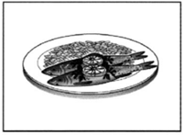 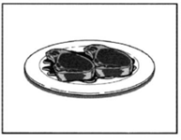 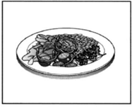

Bốc 7 câu (trong Part 1) ngẫu nhiên, mỗi câu 2 điểm

2. Part 2 (6 điểm):

You will hear an interview with a teenager called Simon about going to an indoor climbing centre that has a climbing wall.

For each question, choose the correct answer A, B or C.

|  |  |  |  |
| --- | --- | --- | --- |
| 8 | Simon’s mum decided to take him to the climbing centre because | A | she had enjoyed going there. |
| B | her friend had recommended it. |
| C | Simon had been there with his school. |
| 9 | Before he went to the centre, Simon was | A | worried about going climbing there. |
| B | interested in seeing the climbing wall. |
| C | disappointed to hear it was all indoors. |
| 10 | Simon says that at the centre there were | A | lots of people when it opened. |
| B | many different types of people. |
| C | no other people his age. |
| 11 | What did Simon think about the climbing wall? | A | He thought it looked very high. |
| B | He was afraid he might fall. |
| C | He found the foot holes helpful. |
| 12 | Why was Simon unhappy with his first climb? | A | He was slower than everyone else. |
| B | He found it hurt his arms. |
| C | He didn’t get to the top. |
| 13 | What does Simon feel he learnt from climbing at the centre? | A | how to improve his fitness |
| B | to think before he does something |
| C | the best way to work with other people |

bốc 1 câu (trong Part 2) ngẫu nhiên (vì 1 câu này có 6 câu con cố định), mỗi câu con 1 điểm

II. Phần Reading: (45 phút)

1. Part 1: (10 điểm)

1. Police ……….. robbers.

A. catch B. catches C. caught D. have caught

Bốc 10 câu (trong Part 1) ngẫu nhiên, mỗi câu 1 điểm

2. Part 2: (5 điểm)

Câu 1:

|  |  |
| --- | --- |
| A. The six - week course is cheaper if you also do the one-day class.  B. The one- day class is free for those who book the six-week course.  C. You must pay for the six-week course before you do the one- day class. |  |

Bốc 5 câu (trong Part 2) ngẫu nhiên, mỗi câu 1 điểm.

3. Part 3: (5 điểm)

**Nội dung:**

**Cliff Jones**

In 2005, Cliff Jones began a journey round Britain on a unicycle, a bike with only one wheel. He had already made a documentary film about his experiences travelling round Europe in a 50-year-old car. He was mad about motor sport and had a job building racing car engines. To save money, Cliff rode to work in London on an old bicycle, which he also used to go to France on holiday. ‘That trip opened my eyes,' he says. ‘I decided to do a tour of Britain by bike.’

Cliff didn’t want a normal touring bike, and he knew he wanted to build one himself. ‘The craziest bicycle I could think of was a unicycle, so I went to a factory to see how they are made.’ After one false start in 2004, when he had to tum back because of a knee injury, he finally set out in 2005. He was away for four months, and travelled over 8,500 km.

The best bit of the trip was arriving in Wales and seeing Mount Snowdon. 'Although I met cyclists who could easily ride up mountains on their bikes, which I couldn’t do, I never regretted my unicycle. The further away from London I got, the more amazed people seemed by it. His worst moment came when he had to drink some dirty water from a stream. A serious fever kept him in bed in hospital for five long days. He was determined not to give up and go back home before he had completed his challenge, but found it hard to carry on because he felt so weak. Yet despite all this, Cliff now says, 'If I could afford it, I would like to do something similar again.’

21. What is the writer trying to do in this text?

A. advise people to take adventure holidays

B. explain a rather unusual choice of transport

C. suggest the benefits of a special vehicle

D. persuade people to travel long distances

22. What made Cliff realise he wanted to cycle round Britain?

A. touring Europe in an old car

B. visiting a unicycle factory

C. attending motor races abroad

D. taking his bike to another country

23. When Cliff met other cyclists in the mountains, he was

A. anxious to get away from them.

B. satisfied with his own type of bicycle.

C. jealous of what they were able to do.

D. surprised by their attitude towards him.

24. What was Cliff's biggest problem during the trip?

A. He fell ill for nearly a week.

B. He had to go home to rest.

C. He wanted to finish his trip early.

D. He took too long to get to one place.

25. What might Cliff say after his trip?

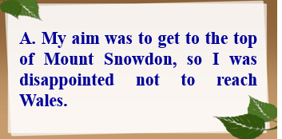 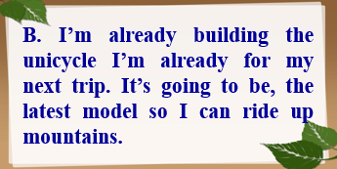

 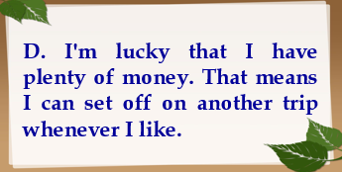

Bốc 1 câu (trong Part 3) ngẫu nhiên (vì 1 câu này có 5 câu con cố định), mỗi câu con 1 điểm

4. Part 4: (10 điểm)

Nội dung:

Read the text below and choose the correct word for each space.

For each question, mark the correct letter A, B, C or D on your answer sheet.

Example:

0 A. brought B. held C. kept D. grown

Answer: A

**Alpacas**

Alpacas were first (0) ............ by the Inca people in the mountains of South America, more than six thousand years ago. These animals (**26**) ............ clothes, food and fuel for their owners. The softest wool was (**27**) ............ worn by the leaders of Incan society though.

When Spanish explorers (**28**) ............ in the fifteenth century, sheep were introduced and these gradually (**29**) ...... alpacas in the region. It wasn’t (**30**) ...... the middle of the 20th century that both farmers and fashion designers began to recognise the (**31**) ......... of alpacas again. They are easy to look (**32**) ......... since they eat grass and are used to low temperatures. Their wool, which comes in a (**33**) .......... of natural colours from white to dark brown, is lighter and warmer than sheep's wool and (**34**) .......... strong. It is not surprising (**35**) .......... that alpacas are becoming a familiar sight in the fields of North America, Australia and the UK.

26. A. supported B. provided C. turned D. gained

27. A. mainly B. fully C. extremely D. absolutely

28. A. reached B. delivered C. arrived D. transferred

29. A. retired B. removed C. returned D. replaced

30. A. until B. after C. during D. before

31. A. prizes B. rewards C. qualities D. points

32. A. at B. after C. for D. like

33. A. row B. group C. range D. crowd

34. A. only B. also C. instead D. too

35 A. therefore B. already C. otherwise D. enough

Bốc 1 câu (trong Part 4) ngẫu nhiên (vì 1 câu này có 10 câu con cố định), mỗi câu con 1 điểm

III. Phần Writing: (45 phút – 30 điểm)

1. Part 1: (10 điểm)

Nội dung

Here are some sentences about a baseball game.

For each question, complete the second sentence so that it means the same as the first.

**Use no more than three words.**

Write only the missing word on your answer sheet.

1. Nick was given a ticket to a baseball game by his friend Akio.

**Nick's friend Akio …………….. him a ticket to a baseball game.**

2. Nick had never been to a baseball game before.

**It was the ……………… Nick had been to a baseball game.**

3. Nick wasn't sure when the match would finish.

**Nick wasn't sure ………….. long the match would go on for.**

4. In the game the Dolphins team played better than the Giants.

**In the game the Giants team didn't play as ……………... the Dolphins.**

5. Now Nick can't wait for the next game.

**Now Nick is really looking .………………. to the next game.**

Bốc 1 câu (trong Part 1) ngẫu nhiên (vì 1 câu này có 5 câu con cố định), mỗi câu con 2 điểm

2. Part 2: (20 điểm)

Bốc ngẫu nhiên 1 đề viết (trong Part 2). Thiết kế khung viết cho người dùng, gửi nội dung viết về cho tài khoản giáo viên hướng dẫn.

IV. Phần Speaking: (10 phút – 20 điểm)

Bốc ngẫu nhiên 1 đề nói (trong Speaking). Thiết kế cho người dùng có thể ghi âm, gửi bài ghi âm về cho tài khoản giáo viên hướng dẫn.